CS 2302 Data Structures

Fall 2019

Lab Report #5

Due: November 1, 2019

Professor: Olac Fuentes

TA: Anindita Nath

**Introduction**

In this lab the task was to implement both hash tables utilizing chaining as the method for hash, as well has hashing utilizing linear probing as the main method of design. The goal after creating both the hash using chaining and the hash using linear probing was to create a program similar to lab 4 where we needed to read a list of words and their vectors. Create an object and store them in the hashing methods and then find a specific pair to determine 2 words similarities.

**Proposed Solution Design and Implementation**

For the lab i wanted to keep the word and its vector together for the duration of its run time. To this end, I want to read a file and immediately convert it to an object and anytime I need to reference a specific word i will retrieve an object containing both a word plus its vector. Every method that required the word only to function receives the created object to ensure that the word never loses its paired set of vectors. I then want to save the list in its new data structure and then build a method that traverses the data structure.

**Experimental Results**

**Part 1:**

This was very simple to implement. Though i was not able to fully test every method due to how long they took to actually run. I recorded a 8 hour test run of the very first bullet and upon further discussion of the runtimes with other students, they were all similarly bad for both chaining and linear probing. I added a counter to be printed as the hash tables are being built and they don't error out so i am under the assumption that the insert method works for both methods of hash.

Here is a snipet of the building of chaining:



Here is a snippet of the linear probing build:

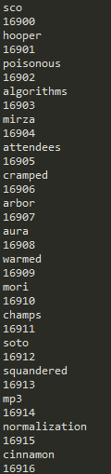

**Part 2:**

This part was hard to fully test due to the run times so i put together a smaller file and test sample to get a similarity list. And show that my find methods work Here are those results.

Chaining:



Linear probing:



**Overall Lab Results:**

After finishing the lab i think hashing can be a really powerful tool in some scenarios but not in every scenario. There's a lot of testing involved in getting a hash table to run as efficiently as possible but in a real world scenario where time is not a limitless resources i can see the appeal of trees that as long as their build right will organize the data faster.

**Conclusion**

This lab was refreshing to do because it was not as hard of a concept as binary trees and trees in general. I have a better understanding of how hashing works and think that i can now utilize this new skill when it proves to be the best solution.

**Appendix**

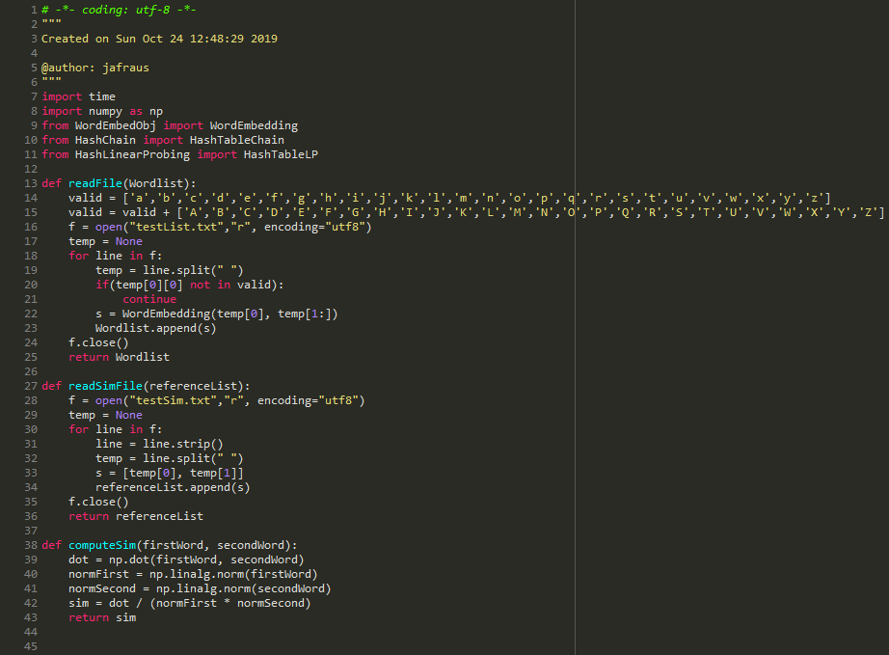

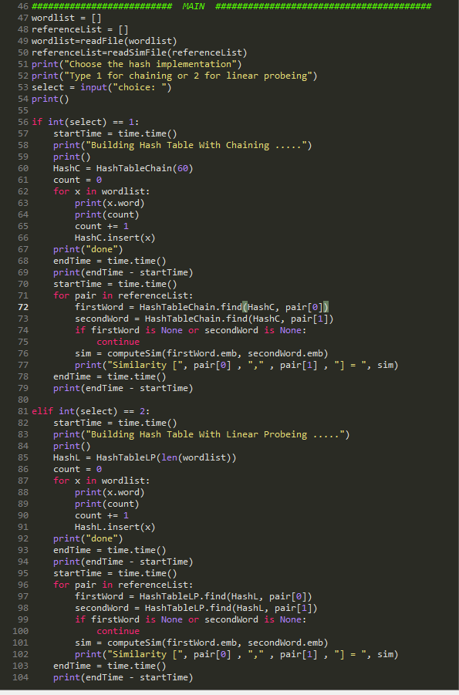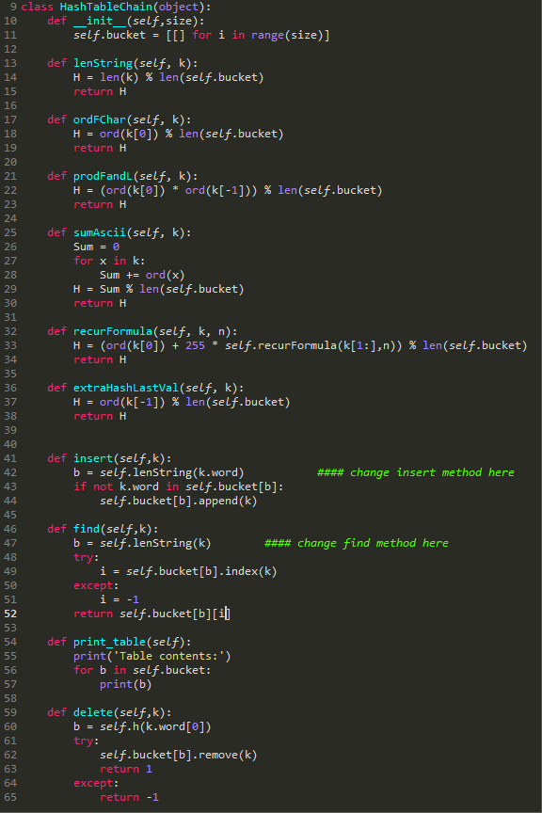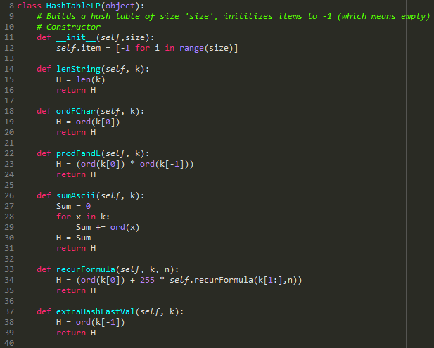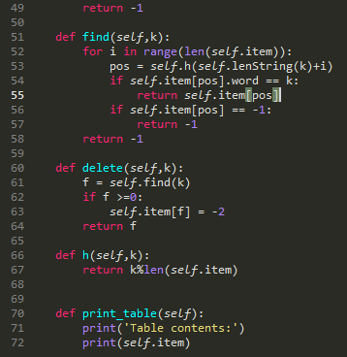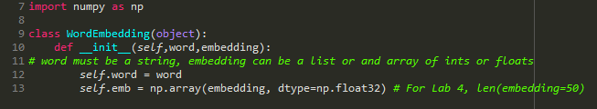

*I certify that this project is entirely my own work. I wrote, debugged, and tested the code being presented, performed the experiments, and wrote the report. I also certify that I did not share my code or report or provided inappropriate assistance to any student in the class*

Justus Frausto